Heap Sort:

Selection Sort:

Merge Sort:

Test case 1

Test case 2

Before : 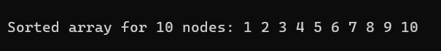

Test case 3

Before: 

After: 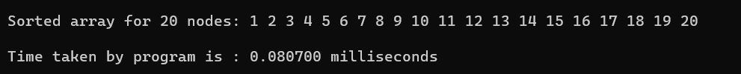

Test Case 4

Before: 

After: 